**CHESS WITH AI**

**Mini Project 1 B Report**

Submitted in partial fulfillment of the requirement of University of Mumbai

For the Degree of

**Bachelor of Engineering**

**By**

1. **Harshit Mhatre ID No: TU8F2122024**
2. **Chaitanya Deokar ID No: TU8F2122037**
3. **Utkarsh Tiwari ID No: TU8F2122025**
4. **Manas Thosar ID No: TU8F2122028**

**Under the Guidance of**

**Prof. Sayalee J. Narkhede**



**Department of Artificial Intelligence & Data Science**

**TERNA ENGINEERING COLLEGE**

**Plot no.12, Sector-22, Opp. Nerul Railway station, Phase-11, Nerul (w), Navi Mumbai 400706**

**UNIVERSITY OF MUMBAI**

**FH-2023**



**TERNA ENGINEERING COLLEGE, NERUL,**

**NAVI MUMBAI**

**Department of Artificial Intelligence & Data Science**

Academic Year 2022-23

**CERTIFICATE**

This is to certify that the mini project 1 B entitled **“Chess with AI”** is a bonafide work of

1. **Harshit Mhatre ID No: TU8F2122024**
2. **Chaitanya Deokar ID No: TU8F2122037**
3. **Utkarsh Tiwari ID No: TU8F2122025**
4. **Manas Thosar ID No: TU8F2122028**

submitted to the University of Mumbai in partial fulfillment of the requirement for the award of the Bachelor of Engineering (Artificial Intelligence & Data Science).

Prof. Sayalee J. Narkhede Dr. Sandeep B. Raskar Dr. L. K. Ragha

**Guide Name Head of the Department Principal**

**Project Report Approval**

This Mini Project 1 B Report – entitled “**Chess with AI**” by following students is approved for the degree of ***B.E. in "Artificial Intelligence & Data Science"***.

**Submitted by:**

1. **Harshit Mhatre ID No: TU8F2122024**
2. **Chaitanya Deokar ID No: TU8F2122037**
3. **Utkarsh Tiwari ID No: TU8F2122025**
4. **Manas Thosar ID No: TU8F2122028**

Examiners Name & Signatures:

1.---------------------------------------------------------

2.---------------------------------------------------------

Date: ---------------------------------

Place: ---------------------------------

**Declaration**

We declare that this written submission represents our ideas in our own words and where others' ideas or words have been included, we have adequately cited and referenced the original sources. We also declare that we have adhered to all principles of academic honesty and integrity and have not misrepresented or fabricated or falsified any idea/data/fact/source in our submission. We understand that any violation of the above will be cause for disciplinary action by the Institute and can also evoke penal action from the sources which have thus not been properly cited or from whom proper permission has not been taken when needed.

1. **Harshit Mhatre ID No: TU8F2122024** ----------------------------
2. **Chaitanya Deokar ID No: TU8F2122037** ----------------------------
3. **Utkarsh Tiwari ID No: TU8F2122025** ----------------------------
4. **Manas Thosar ID No: TU8F2122028** ----------------------------

Date: _____________________

Place: _____________________

**Acknowledgement**

We would like to express our sincere gratitude towards our guide **Prof. Sayalee J. Narkhede**, Mini Project Coordinator **Prof. Ankita A. Mahamune** for their help, guidance, and encouragement, they provided during the project development. This work would have not been possible without their valuable time, patience, and motivation. We thank them for making our stint thoroughly pleasant and enriching. It was great learning and an honor being their student.

We are deeply thankful to **Dr. Sandeep B. Raskar, HOD, AI & DS** and entire team in the Artificial intelligence and data science Department. They supported us with scientific guidance, advice, and encouragement, they were always helpful and enthusiastic and this inspired us in our work.

We take the privilege to express our sincere thanks to **Dr. L. K. Ragha**our Principal for providing the encouragement and much support throughout our work.

1. **Harshit Mhatre ID No: TU8F2122024**
2. **Chaitanya Deokar ID No: TU8F2122037**
3. **Utkarsh Tiwari ID No: TU8F2122025**
4. **Manas Thosar ID No: TU8F2122028**

Date: _____________________

Place: _____________________

**Index**

|  |  |  |
| --- | --- | --- |
| **TABLE OF CONTENTS** | | |
| **Sr. No.** | **Title** | **Page No.** |
|  | **Abstract** | **7** |
|  | **List of Figures** | **8** |
|  | **List of Tables** | **9** |
| Chapter 1 | Introduction   * 1. Motivation   2. Scope of project   3. Aim | 10 |
| Chapter 2 | Problem Statement  2.1 Statement  2.2 Features  2.3 Objectives | 11 |
| Chapter 3 | Literature Survey | 12 |
| Chapter 4 | Design and Implementation  4.1 Tools Used  4.2 Software Components  4.3 Working of the System  4.4 Algorithm | 17 |
| Chapter 5 | Results & Discussion | 20 |
| Chapter 6 | Conclusion and Future Work  6.1 Conclusion  6.2 Future Scope | 22 |
|  | References | 23 |

## Abstract

In this project, we present an advanced chess AI game that aims to provide a challenging and realistic gameplay experience for players. Our AI system has been designed to emulate human-like play, employing sophisticated algorithms and techniques to generate legal moves, evaluate move strengths, and make strategic decisions.

The chess AI game features a user-friendly interface with visually appealing graphics and intuitive controls. Players can choose to play against the AI at varying skill levels, ranging from beginner to advanced. The AI system has been trained using a combination of traditional chess algorithms, such as alpha-beta pruning and minimax search. The AI's evaluation function has been refined through extensive testing and fine-tuning, to provide an accurate assessment of move strengths and to adapt its playing style based on the opponent's moves.

Furthermore, our chess AI game serves as a platform for research and development in the field of artificial intelligence, providing opportunities for experimentation with advanced algorithms and techniques. It also aims to serve as an educational tool for players to improve their chess skills, offering analysis and explanations of the AI's moves to help players understand the game better.

Overall, our advanced chess AI game represents a significant achievement in the field of artificial intelligence, showcasing the capabilities of our sophisticated AI system and providing an engaging and challenging gameplay experience for chess enthusiasts of all skill levels.

**List of Figures**

|  |  |  |
| --- | --- | --- |
| **Sr. No.** | **Name of Figure** | **Page No.** |
| 1 | Fig 4.1: Architecture diagram of Chess AI System | 17 |
| 2 | Fig 4.2: Min-Max Algorithm | 19 |
| 3 | Fig 4.3: Alpha-Beta Pruning | 19 |
| 4 | Fig 5.1: Result 1 | 20 |
| 5 | Fig 5.2: Result 2 | 20 |
| 6 | Fig 5.3: Result 3 | 21 |
| 7 | Fig 5.4: Result 4 | 21 |
|  |  |  |
|  |  |  |
|  |  |  |

**List of Tables**

|  |  |  |
| --- | --- | --- |
| **Sr. No.** | **Name of Table** | **Page No.** |
| 1 | Table 3.1: Literature Survey | 16 |
|  |  |  |
|  |  |  |
|  |  |  |
|  |  |  |

**Chapter 1**

**Introduction**

* 1. **Motivation:**

The game of chess has been a timeless test of strategic and tactical prowess, and developing a chess AI presents an exciting challenge to create a system that can rival human players. A chess AI project offers opportunities for advancing the field of artificial intelligence, pushing the boundaries of algorithm design, machine learning, and neural networks. It can also serve as an educational tool for players to improve their chess skills and provide an entertaining and engaging gameplay experience. With the potential for realistic human-like play, customization options, and research opportunities, a chess AI project is a compelling endeavor for enthusiasts passionate about chess and AI alike.

**1.2 Scope of the project:**

The scope of a chess AI typically includes implementing the rules of chess, designing a board representation, developing move generation and evaluation functions, creating a user-friendly interface, and providing customization options such as difficulty levels and playing styles. It may also involve experimenting with advanced algorithms, and reinforcement learning to optimize the AI's gameplay. The project may aim to provide a realistic and challenging chess-playing experience, offer educational insights, and serve as a platform for research and development in the field of artificial intelligence.

**1.3 Aim:**

The aim of the chess AI project is to develop a high-performance artificial intelligence system that can play chess at a competitive level, providing a realistic and challenging gameplay experience for players. The project may focus on implementing advanced algorithms, and reinforcement learning to optimize the AI's gameplay, while also offering educational insights and serving as a platform for research and development in the field of artificial intelligence.

**Chapter 2**

**Problem Statement**

**2.1 Statement:**

The problem addressed in the chess AI project is the development of an artificial intelligence system that can effectively play chess at a competitive level, emulating or surpassing human players. The challenges include designing algorithms to generate legal moves, evaluating the strengths of different moves, and making strategic decisions based on the current game state. The AI system must be able to handle complex branching factors, search efficiently within the limited time constraints of a game, and adapt its playing style based on the opponent's moves. Additionally, the AI should provide a realistic and challenging gameplay experience for players, while also offering educational insights and serving as a platform for research and development in the field of artificial intelligence. The problem statement encompasses the various technical, strategic, and educational aspects of developing a sophisticated and high-performing chess AI system.

**2.2 Features:**

1. Fully functional chess engine with legal move generation, piece movement, and strategic decision-making.

2. User-friendly interface with visually appealing graphics and intuitive controls.

3. Option to play against the computer AI or with other human players

4. Potential as a research and development platform for experimenting with advanced AI algorithms and techniques.

* 1. **Objectives:**

The main objective of the chess AI game is to create a high-performance artificial intelligence system that can play chess at a competitive level, providing a challenging and realistic gameplay experience for players. The AI system should be capable of generating legal moves, evaluating move strengths, making strategic decisions, and adapting to opponent moves. The game may also aim to offer customization options, user-friendly interface, analysis and feedback for player improvement, and potential for research and development in the field of artificial intelligence.

**Chapter 3**

**Literature Survey**

|  |  |  |  |  |  |
| --- | --- | --- | --- | --- | --- |
| **Sr. No.** | **Paper Details**  **Authors, “Title”, Resource Name, Year, page nos.** | **Problem Addressed** | **Methodology Used** | **Advantages/ Strengths Found** | **Disadvantages/ Limitations/Gaps Found** |
| 1 | Robert Levinson, Feng-hsiung hsu, T. Anthony Marsland, Jonathan Schaeffer and David E. Wilkins, January 1991, “Role of chess in artificial intelligence research”, Proceeding of the 12th International Joint Conference on Artificial Intelligence, 547-542. | Expert Inputs are Sometimes Harmful  Open Problem and Lessons for AI. | Given a patient and seemingly perfect teacher (chess-playing machine), how should one use it to "teach" an Al-based learning program about strategies for playing chess | The main objectives of the project are to demonstrate capacity of the system to learn, to deepen our understanding of the interaction of knowledge and search, and to build bridges in this area between AI and cognitive science. | The alternative AI approaches have not fared well, perhaps because of the expense in applying the knowledge that had been supplied to the system. |

|  |  |  |  |  |  |
| --- | --- | --- | --- | --- | --- |
| **Sr. No.** | **Paper Details**  **Authors, “Title”, Resource Name, Year, page nos.** | **Problem Addressed** | **Methodology Used** | **Advantages/ Strengths Found** | **Disadvantages/ Limitations/Gaps Found** |
| 2 | Vladimir Karapetyan, December 2021, “Functions of algorithmic thinking in the process of demonstrating chess skills”, Problems of Psychology in the 21st Century, vol. 15, 48-52. | New ideas will not come to you if you sit down and wait for them. Talk to people, watch the world, get out of the closed house-work chain, ask yourself questions and look for the answers. | The application of thinking schemes with complete observations, are sequential actions that develop the child’s intellectual abilities with both logical and pictorial thinking | The value of algorithmic thinking as a necessity for a new type of educational outcome is focused on accomplishing or solving real-life tasks. | Algorithmic moves cannot always be winning as it can also go wrong. Also, it takes huge amounts of time to develop that kind of logical thinking and a lot of practice. |

|  |  |  |  |  |  |
| --- | --- | --- | --- | --- | --- |
| **Sr. No.** | **Paper Details Authors, “Title”, Resource Name, Year, page nos.** | **Problem Addressed** | **Methodology Used** | **Advantages/ Strengths Found** | **Disadvantages/ Limitations/Gaps Found** |
| 3 | Shiva Maharaj, Nick Polson and Alex Turk, April 2022, “Chess AI: Competing Paradigms for Machine Intelligence”, Entropy 24(4):550. | Testing two of the leading chess engines , stockfish and LCZero to show which is more efficient. | We choose to analyze how chess engines respond to Plaskett’s Puzzle, one of the most well-known endgame studies in history. The endgame is the final phase of a chess game. | The highly inventive puzzle involves multiple underpromotions and was originally designed to be a checkmate in 14 moves. | There is a mistake in the original puzzle whereby Black can escape checkmate, though White is still winning in the final position. |

|  |  |  |  |  |  |
| --- | --- | --- | --- | --- | --- |
| **Sr. No.** | **Paper Details**  **Authors, “Title”, Resource Name, Year, page nos.** | **Problem Addressed** | **Methodology Used** | **Advantages/ Strengths Found** | **Disadvantages/ Limitations/Gaps Found** |
| 4 | Jimeet Viren Shah, December 2020, “Minimax algorithm”. | With the help of the paper, the aspect of involvement of Artificial intelligence in games involving physical objects like chess, cards and even dominoes, which are quite popular in public. | With the settings in min-max algorithm , one can observe the individual by maximising his/her score , while rival trying to minimise the individual’s score. | The minimax algorithm helps in decision making, with the main objective being: to the best possible and optimal move. | The algorithm behave much more intelligently but, with the drawback of not being able to learn anything. |

|  |  |  |  |  |  |
| --- | --- | --- | --- | --- | --- |
| **Sr. No.** | **Paper Details**  **Authors, “Title”, Resource Name, Year, page nos.** | **Problem Addressed** | **Methodology Used** | **Advantages/ Strengths Found** | **Disadvantages/ Limitations/Gaps Found** |
| 5 | Gaurav Parihar and Raghavendra R, April 2022, “Chess playing AI”, International Journal of Creative Research Thoughts (IJCRT), vol.10, 2320-2882. | Automation have been originally conceived to surpass humans in pre-calculated techniques that might be tiresome and predictable. Artificial Intelligence, on the other hand, can provide decision-making power to make different movements and learn some new. | It uses artificial intelligence techniques as with the Minimax Algorithm and the Monte Carlo Algorithm to acquire the maximum payoff and benefit over the opposition in the current situation. | Gaming with a similar personal computer with from before the challenges is common and, at times, boring. As a result, AI enters the picture in this scenario. Regardless, it has two distinct AIs with different tactics to make the things more interesting since it simulates, analyzes, and decides in the same manner that people do. | Choice tree-based designs require too long to search through the exact and full possibility set for the proper decision, limiting the machine's capability. |

Table 3.1: Literature Survey

**Chapter 4**

**Design and Implementation**

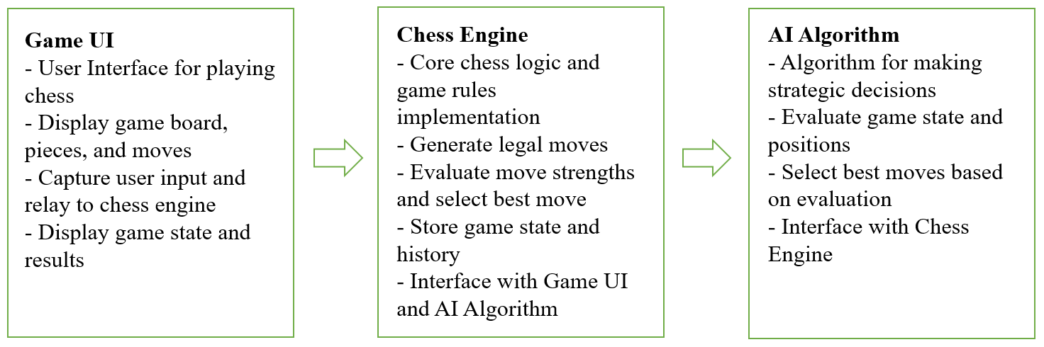

Fig 4.1: Architecture diagram of Chess AI System

**4. 1 Tools Used:**

Programming Language: A programming language Python

Development Environment: An Integrated Development Environment (IDE): PyCharm

**4.2 Software Components:**

Game UI: The user interface component that allows players to interact with the game, including displaying the game board, pieces, and moves, capturing user input, and displaying the game state and results.

Chess Engine: The core chess logic and game rules implementation component that generates legal moves, evaluates move strengths, stores game state and history, and interfaces with the AI algorithm and Game UI.

AI Algorithm: The algorithmic component that makes strategic decisions for the AI player, including evaluating the game state and positions, selecting the best moves based on evaluation, and interfacing with the Chess Engine.

**4.3 Working of the System:**

The Game UI displays the chessboard, pieces, and available moves to the player, and captures user input for moves.

The Chess Engine receives the user input from the Game UI, generates legal moves, and evaluates the game state based on the current board position.

The AI Algorithm interfaces with the Chess Engine, receives the evaluated game state, and makes strategic decisions for the AI player.

The AI Algorithm selects the best move based on its evaluation and communicates it to the Chess Engine.

The Chess Engine updates the game state, moves the pieces on the board, and communicates the updated state to the Game UI.

The Game UI displays the updated game state to the player, and the process continues until the game is over.

**4.4 Algorithm:**

Legal Move Generation: The chess AI game needs to generate legal moves for each piece on the board based on its type, position, and the game state. This can be done using algorithms such as bitboards, magic bitboards, or move generation tables.

Move Evaluation: Once the legal moves are generated, the game needs to evaluate the strengths of each move to determine the best move to play. This can be done using algorithms such as minimax, alpha-beta pruning, or neural networks, which evaluate the potential outcomes of different moves based on the current game state and the future game states after a series of moves.

Move Selection: After evaluating the strengths of different moves, the game needs to select the best move to play. This can be done by choosing the move with the highest evaluation score, or by using additional criteria such as piece values, mobility, pawn structure, or positional considerations to prioritize certain moves over others.

The Minimax algorithm is a decision-making algorithm commonly used in game theory, artificial intelligence, and decision analysis. It is used to determine the best move or action in a zero-sum, two-player game, where the goal is to maximize the player's own score while minimizing the opponent's score.

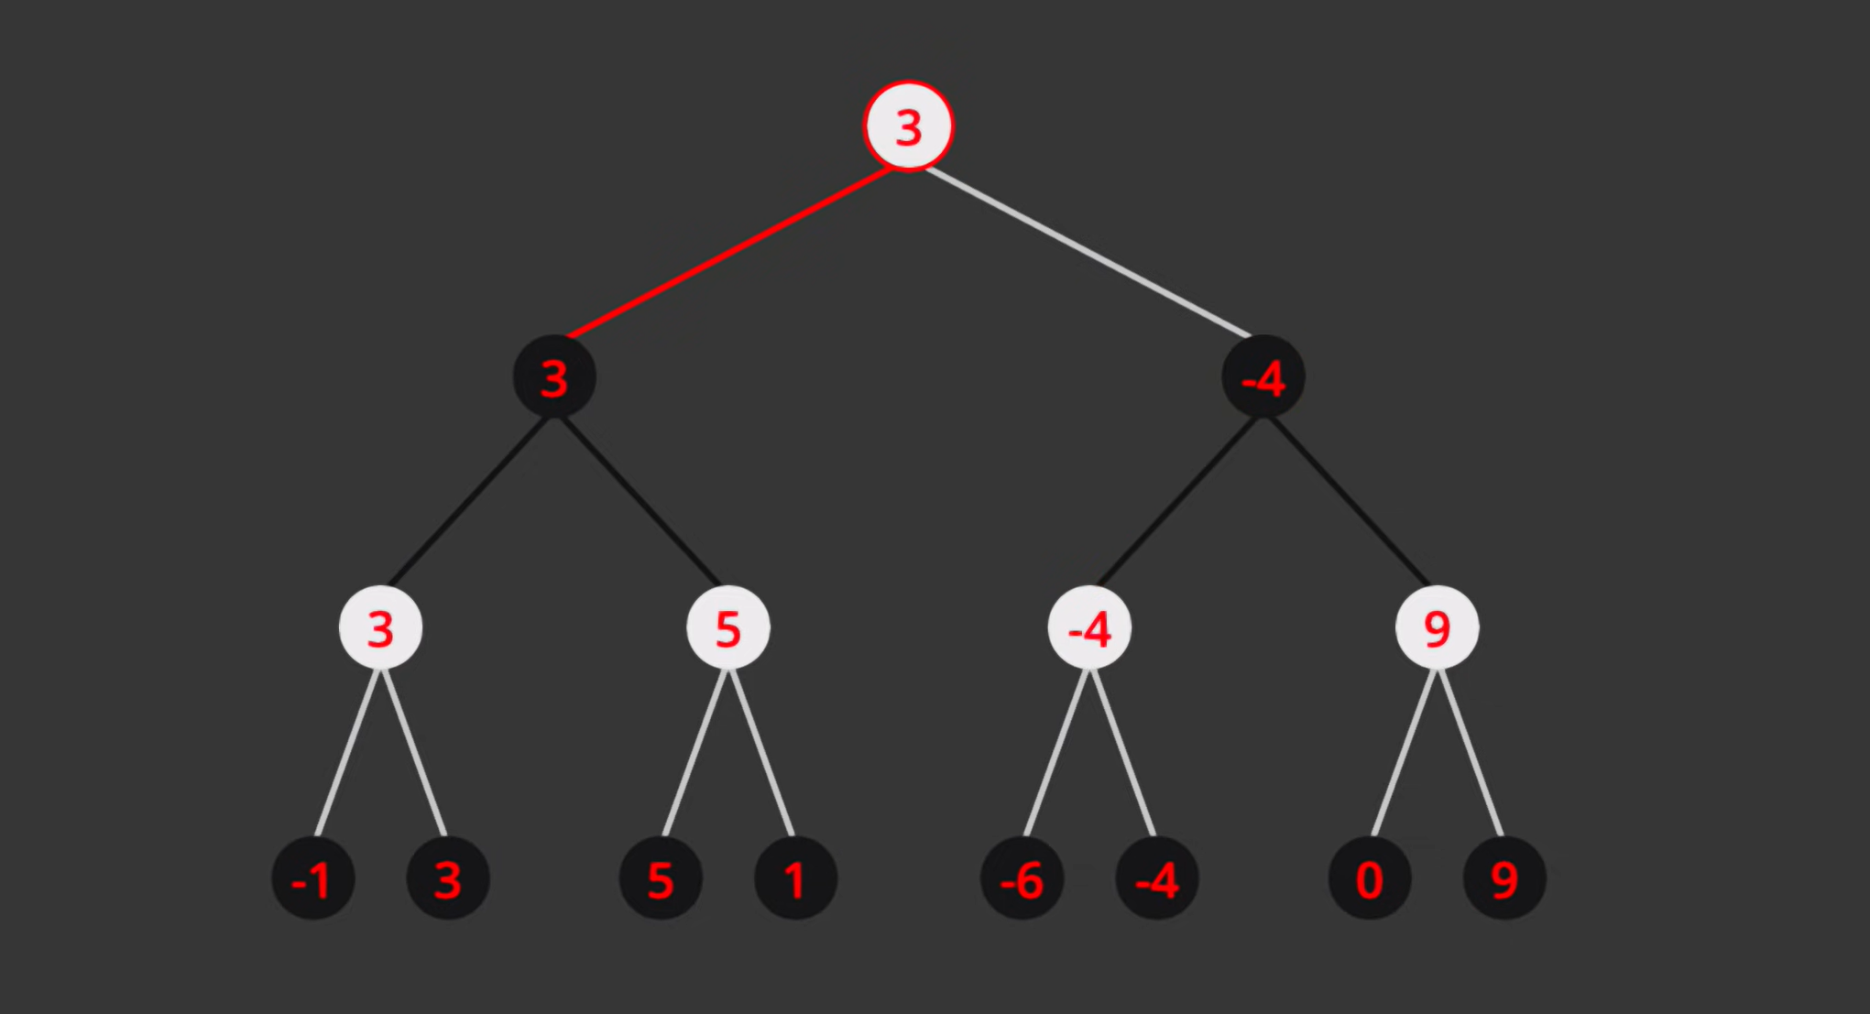

Fig 4.2: Min-Max Algorithm

Alpha-beta pruning is a search optimization technique used in the Minimax algorithm to reduce the number of nodes that need to be evaluated in a game tree. It is designed to speed up the Minimax algorithm by pruning or cutting off branches of the game tree that are known to be suboptimal, without affecting the final decision.

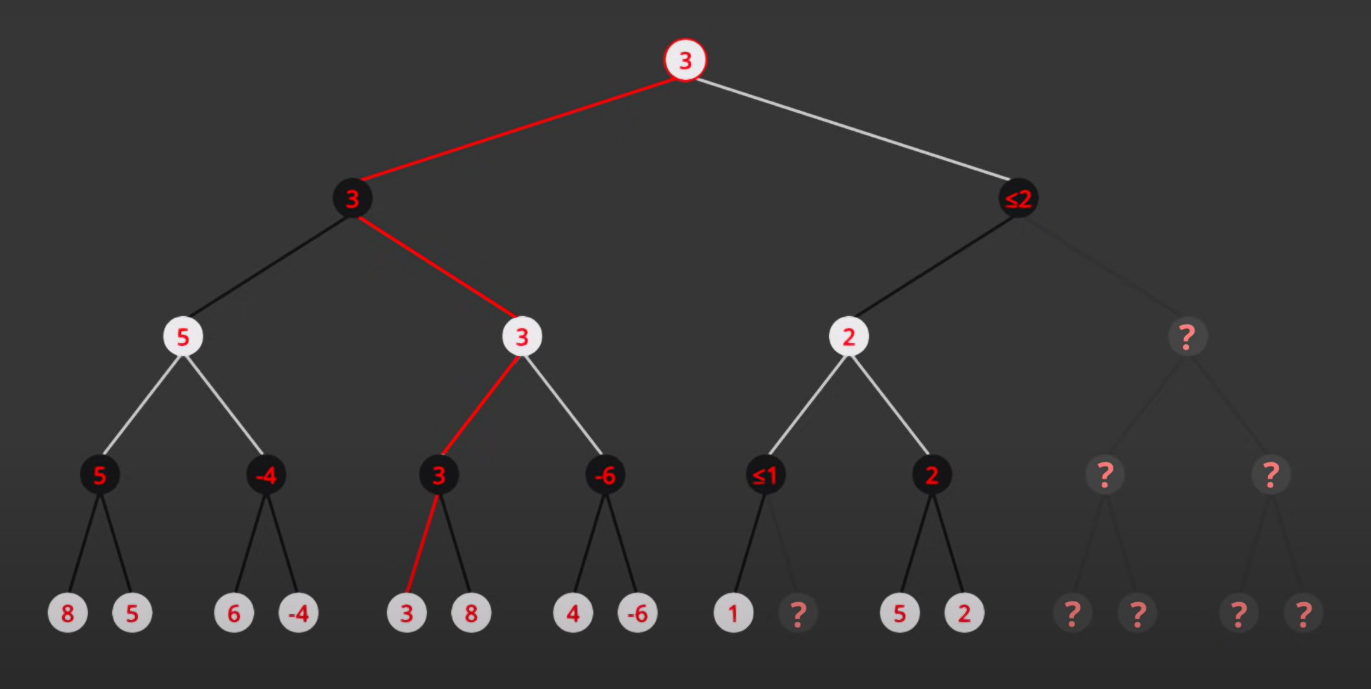

Fig 4.3: Alpha-Beta Pruning

**Chapter 5**

**Results**

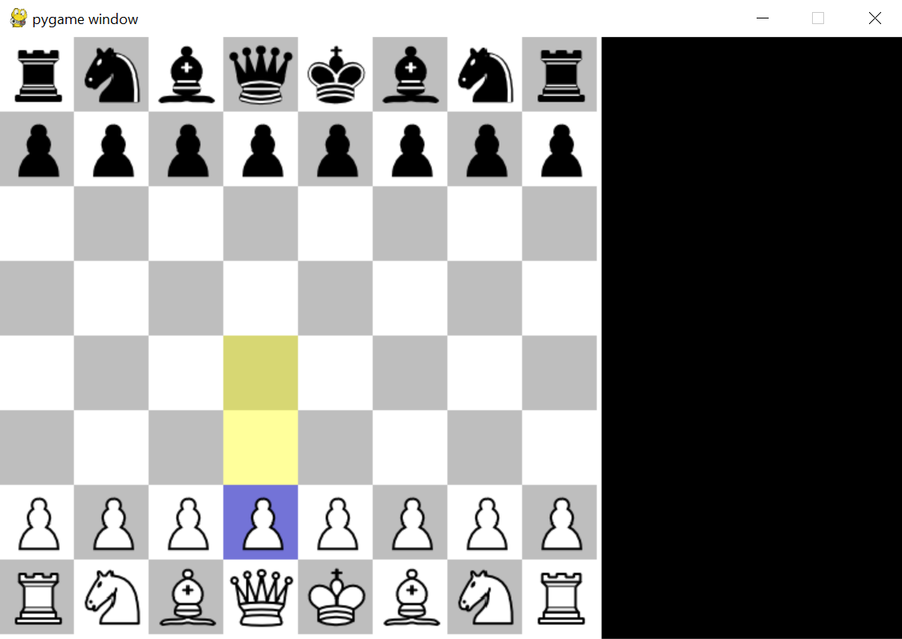

Fig 5.1: Result 1

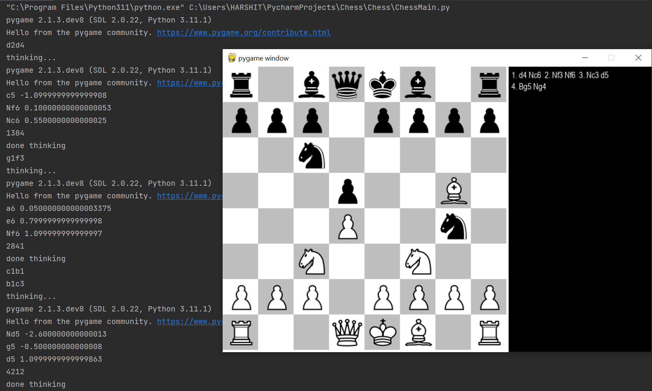

Fig 5.2: Result 2

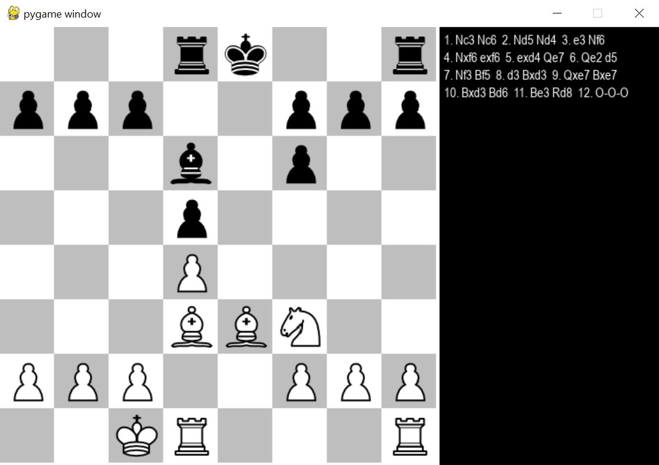

Fig 5.3: Result 3

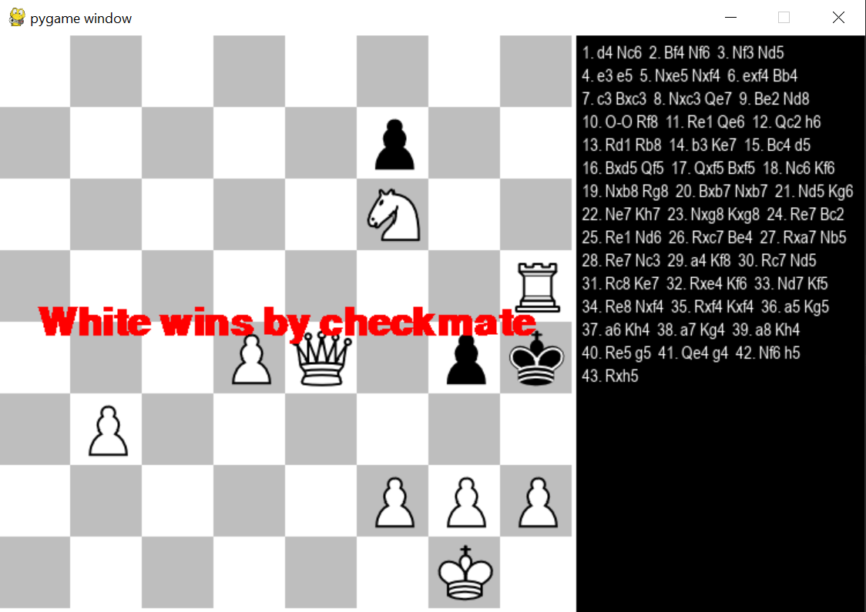

Fig 5.4: Result 4

**Chapter 6**

**Conclusion and Future Scope**

**6.1 Conclusion:**

Successfully created a chess game with AI, by the help of various algorithms and techniques, which can be helpful for analysis, entertainment, and training.

**6.2 Future Scope:**

Improving the AI by adding different openings, data from grandmasters gameplay and developing better algorithms. Enhancing AI capabilities, advanced gameplay features, improved UI/UX, customization options, online integration, cross-platform support, educational features, and continuous improvement based on user feedback and technology advancements.

**References**

[1] Robert Levinson, Feng-hsiung hsu, T. Anthony Marsland, Jonathan Schaeffer and David E. Wilkins, January 1991, “Role of chess in artificial intelligence research”, Proceeding of the 12th International Joint Conference on Artificial Intelligence, 547-542.

[2] Vladimir Karapetyan, December 2021, “Functions of algorithmic thinking in the process of demonstrating chess skills”, Problems of Psychology in the 21st Century, vol.15, 48-52.

[3] Shiva Maharaj, Nick Polson and Alex Turk, April 2022, “Chess AI: Competing Paradigms for Machine Intelligence”, Entropy 24(4):550.

[4] Jimeet Viren Shah, December 2020, “Minimax algorithm”.

[5] Gaurav Parihar and Raghavendra R, April 2022, “Chess playing AI”, International Journal of Creative Research Thoughts (IJCRT), vol.10, 2320-2882.